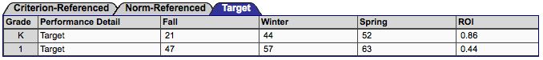
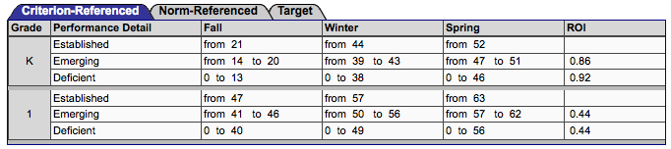
Letter Name

Letter Sound
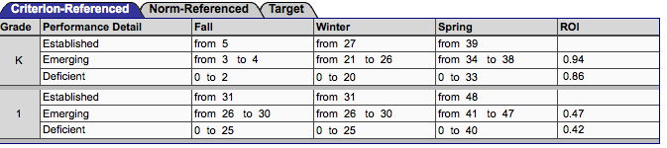
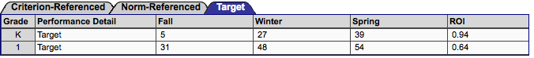

Phoneme Segmentation
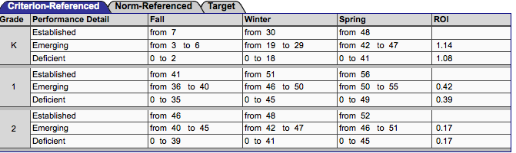
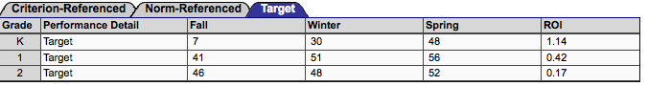

Nonsense Word Fluency

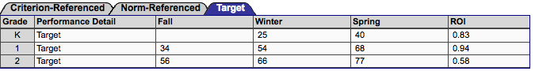

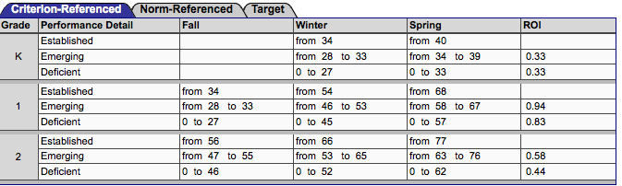

Reading Curriculum Based Measurement (RCBM)
